Note: This document is “view only”. Please create a copy of this document and save it to your drive.

**SOP- Updating Plugins, Themes and WP Versions- Systems Vault**

**PREREQUISITES**

[Master: SOP- Operations Management -Systems Vault](https://docs.google.com/document/u/0/d/1gIeHLaKTWivg43RAx2fHPd14QktmUju8dcElYWywAXM/edit)

[Sarahnoked.com backups folder](https://drive.google.com/drive/u/1/folders/1MhF10z6uGM6DvMwIoZOnHSNu0YzDMVY1)

[Members.sarahnoked.com backups folder](https://drive.google.com/drive/u/1/folders/1ZqXKktJXipk5rZm95qI6FfCcvCsr59aR)

Access to:

[sarahnoked.com](http://sarahnoked.com/wp-admin) site

[Members.sarahnoked.com](http://members.sarahnoked.com/wp-admin) site

**PURPOSE**We keep all Sarah Noked websites up to date to avoid hacking and server down time.

**POLICY**

This task happens weekly.

**PARTY**

Tech VA

**PROPERTY**

Tech VA

**PROCESS**

Part 1: Check for plugin and theme updates

Part 2: Spot check pages on the front end for issues

Part 3: Troubleshoot issues

**PROCEDURES**

**Part 1: Check for plugin and theme updates**

1. Login to [sarahnoked.com](http://sarahnoked.com/wp-admin) and [members.sarahnoked.com](http://members.sarahnoked.com/wp-admin) wordpress account
2. Once you’re on the backend of the site, navigate to the top bar and click the icon for updates 



1. Decide which plugins and themes to update.

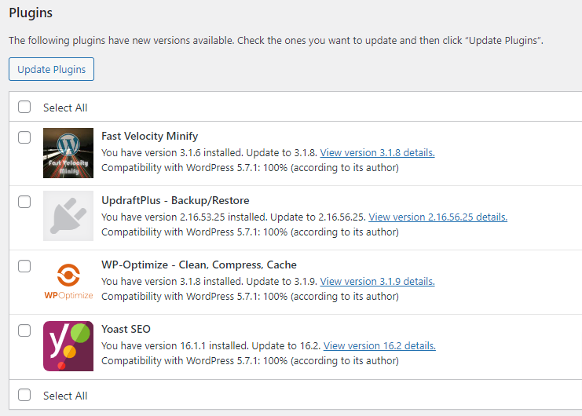

1. Accept the updates and refresh the page at the end to see if there are any left.

**Part 2: Spot check pages on the front end for issues (VERY IMPORTANT!)**

1. Navigate to the front end of the site in an incognito window.
2. Spot check pages to ensure the plugin/theme updates didn’t distort any functionality of the website.
   1. Homepage
   2. Blog post
   3. Resources page
   4. About page
   5. Course dashboard page
3. Keep your eyes out for any links that don’t work or other problems on the website and notify the PM via TWChat or in the task itself.
4. If you’ve updated the Yoast SEO, access backend of WP to see if it is still there
   1. Access the backend
   2.  > Add New
      1. On the right side of the page you should see this:
      2. 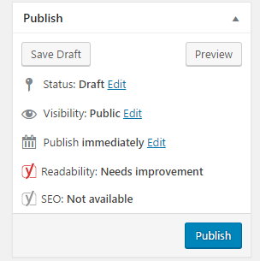
      3. If you do not see the Readability and SEO as seen above, it means that Yoast is no longer downloaded on the website
   3. Re-download Yoast SEO.  > Add New
      1. Search for the plugin Yoast SEO
      2. Download it
      3. Activate it
      4. Repeat step 3b. To check if it is now downloaded correctly

**Created by:**

**Department:** Operations & Support

**Date:**

**Revised:**

**Revised By:**